Employment of Technical and Vocational Education and Training Graduates in Indonesia

Daniel Rizky Bimo Hantoro

Northeastern University, Boston, MA, USA

# Abstract

This report discusses about a business idea about solving the employment problem in Indonesia specifically for TVET (Technical and Vocational Education and Training) graduates that are not provided with integral skills that private sector companies requires. Thus, this database design is aimed to help facilitate the communication between educational institutions, private sector companies and the government in order to help improve the curriculum and lack of targeted investment the government has done to help the decline of TVET in the country. Thus, the database design and queries developed has assisted in selecting parts of the economy, locations and educational institutions that the government needs provide closer attention.

# Introduction

Presently, Indonesia is experiencing a transitional phase economically to becoming a well-developed nation, while that goal is still miles ahead, the country is eager to develop their knowledge-based economy through increasing their competitiveness and employment performance. In order to close the gap between the low education standard between the country and other developed nations, the Indonesian government has invested massively in transforming the (Technical and Vocational Education and Training) TVET sector. However, the biggest challenge that is hampering the country is the fundamental mismatch, as it is stated in the Indonesia Development Forum in 2019 that “Indonesia’s TVET system lacks quality, in part because teaching and learning is not effective or efficient, and the skills that are taught are not always well-matched to the needs of industry.[1]” Moreover, the country is riddled with fake agencies that are scamming unemployed vocational school graduates with fraudulent job openings. Thus, the need for a way to improve the security and communication between educational institution and private sectors is essential in improving the quality and diversity of human capital in the country. Since companies are not forthright to educational institutions on indicating the important skills that employees need to have in order to gain employment, the government should be proactive in mediating between these two parties. However, they’ve not been able to do so causing a mismatch of skills in all of the economic sectors in the country.

Figure 1: Occupational Mismatch in Indonesia

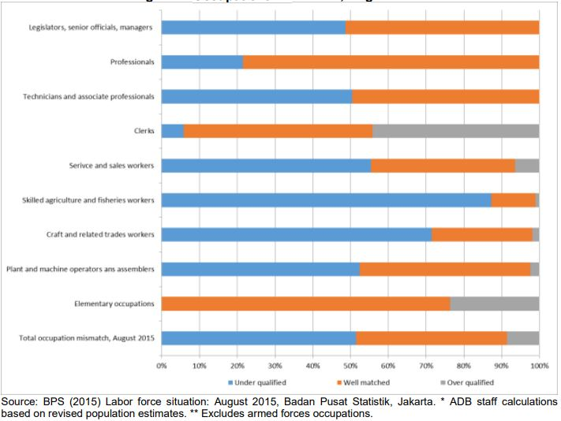

Thus, the database design that I’ve built will be a mockup of a job application website that I want to develop in the future, that is focused in making job openings visible for vocational student graduates and improving the efficiency and effectivity of the job market in the country. Through implementing important factors in the job market like industry, location, supply of vocational school graduates and quality of vocation schools the database will be aimed to help show the actual demand and supply of the job market in different industries and provinces in the country. By considering the quality of schools and the requirements of hiring companies, the database could help the government in selecting schools that actually needs investments and communicate important curriculums to improve TVETs in the country.

# Database Design

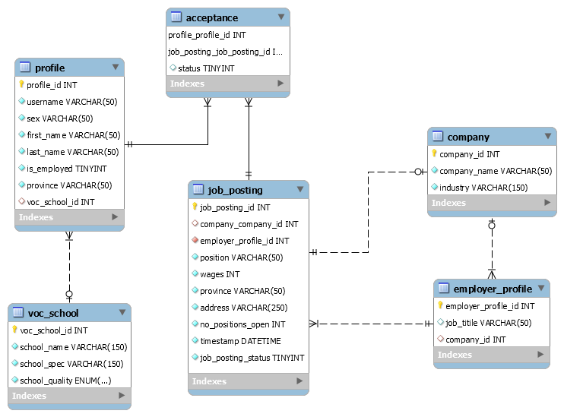

Vocational School and Profile

Profiles are users who are looking for job openings and are either students from a vocational school or any other person looking for a job that has a first name, last name, a Boolean value that determine if they’re employed and province that they reside. Vocational schools are educational institution that refer to either secondary or post-secondary education. The students that pursue a degree in TVET are students that are looking to be working class workers with appropriate skills after graduating. Vocational school have a name, specialty and quality, these factors determine if they’re providing students adequate training in a specific industry.

Companies and Employer Profile

Companies are private sectors within a certain industry that has one to many employer profiles that servers as an admin to profiles that are seeking job openings. These employers are either a part of a company or a freelance employer that is seeking to employ someone within the job market.

Job Posting and Acceptance

Job postings are the job openings that are posted by employer profiles that represent a company, an employer looking to make a job opening for freelance position or by the whole company with a representative as the one who determines if a worker is employed. These openings have a position, wage, skill level needed, province, address, number of this specific position is available, timestamp and a status that represent if the job opening is available. This entity has a many to many relationships with profiles, since profiles can apply to zero to many job postings and many job openings can be linked to zero to many profiles. Job openings itself can be filled by one or more profiles based on the company’s needs.

# Data Sources and Methods

The Indonesian workforce as reported by the Indonesian Central Bureau of Statistics (BPK) reported that in February 2019, there were 136,183,032 employed workers in Indonesia. However, for simplicity I’ve chosen to pick 9 provinces in the country and divide the total employment population by 20 people, as shown by the data below [2].

Provinces with the most total workforce: (20 people)

East Java – 21.588.820-> 5

West Java – 23.835.770-> 5

Central Java – 18.588.970-> 4

DKI Jakarta – 5.447.511-> 1

North Sumatra – 7.450.802 -> 2

Bali – 2.539.578->1

South Sulawesi – 4.159.838-> 1

Riau – 3.296.472-> 1

West Kalimantan– 2.573.617-> 1

Total: 89,481,378

Moreover, the Indonesian workforce is actually divided into 7 main sectors, agriculture, manufacturing, construction, trade or tourism, transportation, financial and social services [3]. However, for simplicity I’ve chosen 4 largest sectors that define the Indonesian economy, which are described below:

Main sectors in the Indonesian Workforce: (4 Largest Sectors in the Indonesian Economy)

Agriculture: modified 45.14%, actual 34%

Tourism & Trade: modified 28.76%, actual 21,66%

Manufacturing: modified 17.67%, actual 13,31%

Construction: modified 8.43%, actual 6,35%

The actual data in total represent around 75.32% and this represent the total percentage of the modified percentage. Thus, the 20 people that have been chosen are divided into vocational schools that represent 4 of the main sectors in the Indonesian economy. Moreover, based on figure 1, the job postings and vocational schools are ranked by poor, decent and great. The quality that’s been chosen for each school and job postings are decided by the percentage on figure 1.

# User Cases

1. How many employed and unemployed workers are there per industry?

SQL Query:

select tmp.voc_school_specialty, total_employed_workforce, total_unemployed_workforce

from (

select voc_school_specialty, count(profile.profile_id) as total_employed_workforce

from profile

join voc_school on (voc_school.voc_school_id = profile.voc_school_id)

where is_employed = true

group by voc_school_specialty) as tmp

join

(select voc_school_specialty, count(profile.profile_id) as total_unemployed_workforce

from profile

join voc_school on (voc_school.voc_school_id = profile.voc_school_id)

where is_employed = false

group by voc_school_specialty) as tmp2

on tmp.voc_school_specialty = tmp2.voc_school_specialty;

Result:

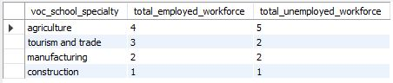

1. How many employed and unemployed workers are there per province?

SQL Query:

select tmp2.province, total_employed_workforce, total_unemployed_workforce

from (

select profile.province, count(profile.profile_id) as total_employed_workforce

from profile

where is_employed = true

group by profile.province) as tmp

right join (

select profile.province, count(profile.profile_id) as total_unemployed_workforce

from profile

where is_employed = false

group by profile.province) as tmp2

on tmp.province = tmp2.province;

Result:

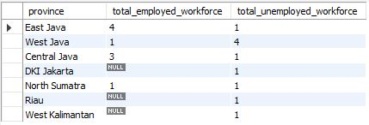

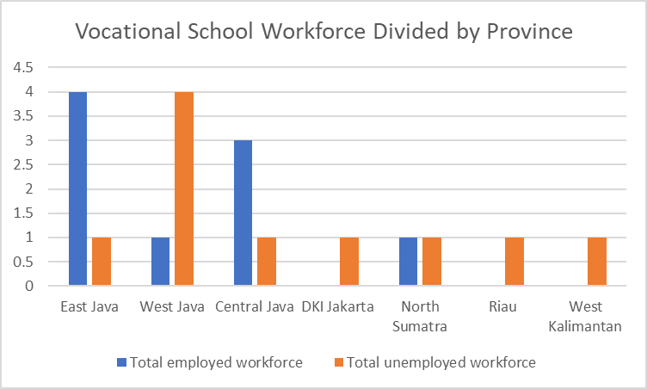

1. How many suitable candidates are there for the open positions in the job market?

SQL Query:

select industry, skill_level, open_positions, num_candidates

from

(select industry, job_posting.skill_level, sum(no_positions_open) as open_positions

from job_posting

join company on (job_posting.company_id = company.company_id)

group by industry, job_posting.skill_level) as tmp

left join (

select voc_school_specialty, voc_school.voc_school_quality, count(profile.profile_id) as num_candidates

from profile

join voc_school on (voc_school.voc_school_id = profile.voc_school_id)

where profile.is_employed = false

group by voc_school_specialty, voc_school_quality) as tmp2 on (tmp.industry = tmp2.voc_school_specialty and tmp.skill_level = tmp2.voc_school_quality);

Result:

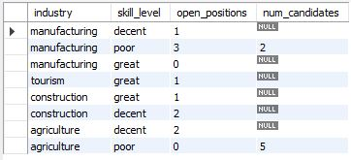

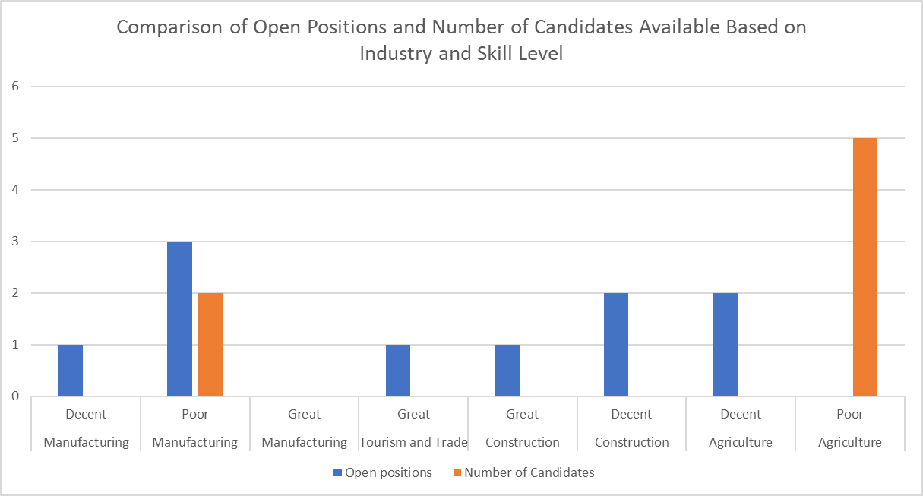

1. Who are the employed workers that have mismatched skills in their employment?

SQL Query:

select profile.first_name, profile.last_name, industry, position, skill_level as required_skill_level, voc_school.voc_school_quality as actual_skill_level

from profile

join

(select position, profile_id, skill_level, industry

from acceptance

join job_posting on (acceptance.job_posting_id = job_posting.job_posting_id)

join company on (job_posting.company_id = company.company_id)

where acceptance.status = true) as temp

on temp.profile_id = profile.profile_id

join voc_school

on profile.voc_school_id = voc_school.voc_school_id

where skill_level <> voc_school_quality;

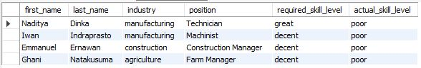

1. What happens when a worker gets hired in the website?

DELIMITER //

create trigger employee_hired

after update on acceptance

for each row

begin

if (old.status = false or old.status is null and new.status = true) then

update profile

set is_employed = true

where new.profile_id = profile.profile_id;

update job_posting

set no_positions_open = no_positions_open - 1

where new.job_posting_id = job_posting.job_posting_id;

update job_posting

set job_posting_status = false

where new.job_posting_id = job_posting.job_posting_id and

job_posting.no_positions_open = 0;

end if;

end //

DELIMITER ;

Test case:

update acceptance

set status = true

where profile_id = 23 and job_posting_id = 1;

Result:

Job_posting_id 1: no_positions_open: 1 –> 0 and job_posting_status = 0

Profile_id 23: is_employed: true

# Conclusions

In conclusion, the database design and queries of a mockup business idea was able to grasp some of the scope of the educational problems that Indonesia is facing specifically in selecting parts of the economy and schools that needs to be invested. As targeting specific economic sectors, locations and improvement in schools especially through reforming TVET’s curriculum is integral in matching the demand of required skills that companies in private sectors need. Since this business idea’s main focus is to improve the communication that happens between private sectors and education institutions, the queries listed above was able to determine that three out of four sectors in the economy which are construction, agriculture and manufacturing needs to be invested further. However, since there is a limited number of schools, economic sectors and possibly inaccurate assumptions, that are listed in the database, the queries could only answer restricted and basic questions about TVET and employment situation in the country. Moreover, Since there is a mismatch of skills that private sectors need from TVET graduates, as reported by the Jakarta Post, “ The apparent gloomy state of vocational school students ignores the decisive role that vocational education will play as the country is anticipating a big harvest of its demographic bonus between 2020 and 2035.[4]” Thus, failure in improving their vocational education, will thwart Indonesia progress in joining the ranks of high GDP per capita countries. In the future, I hope through implementing this business idea, I could be able to improve the lives of Indonesian student through incentivizing the government and providing a helping hand through data science.

# References

1. “Reforming the Vocational Education and Training (TVET) System for Future Jobs.” *Indonesia Development Forum 2019*, Kementrian PPN / Knowledge Sector Initiative, 2019, indonesiadevelopmentforum.com/2019/call-for-submissions/theme/2-reforming-the-vocational-education-and-training-tvet-system-for-future-jobs.
2. “Penduduk Berumur 15 Tahun Ke Atas Menurut Provinsi Dan Jenis Kegiatan Selama Seminggu Yang Lalu, 2008 - 2019.” *Badan Pusat Statistik*, 2019, www.bps.go.id/statictable/2016/04/04/1907/penduduk-berumur-15-tahun-ke-atas-menurut-provinsi-dan-jenis-kegiatan-selama-seminggu-yang-lalu-2008---2019.html.
3. RITONGA, RAZALI. “KEBUTUHAN DATA KETENAGAKERJAAN UNTUK PEMBANGUNAN BERKELANJUTAN.” *BADAN PUSAT STATISTIK*, 2019, bulelengkab.go.id/assets/instansikab/126/bankdata/data-kebutuhan-data-ketenagakerjaan-untuk-pembangunan-berkelanjutan-33.pdf.
4. Board, Editorial. “Big Role for Vocational Schools.” *The Jakarta Post*, 10 Oct. 2019, 08:06 am, www.thejakartapost.com/academia/2019/10/10/big-role-for-vocational-schools.html.